# Lab 3. Motor Control:

1. Get a power transistor and motor from the TA.
2. You will be using an N-channel MOSFET to control a current larger than the Arduino can deliver. Please be careful if using the variable power supply. Start the voltage low and do not use more current than the power transistor can handle. Look up the spec sheet for the power transistor you are given.  
   Part number of your transistor: ______IRFZ44N_______  
   Rated maximum resistance when on: _____17.5mΩ_________  
   Maximum current through the transistor: __49A________
3. Hand-draw a diagram of the transistor you are using (or paste in a picture from the spec sheet) showing which pin is Gate, Source, and Drain.

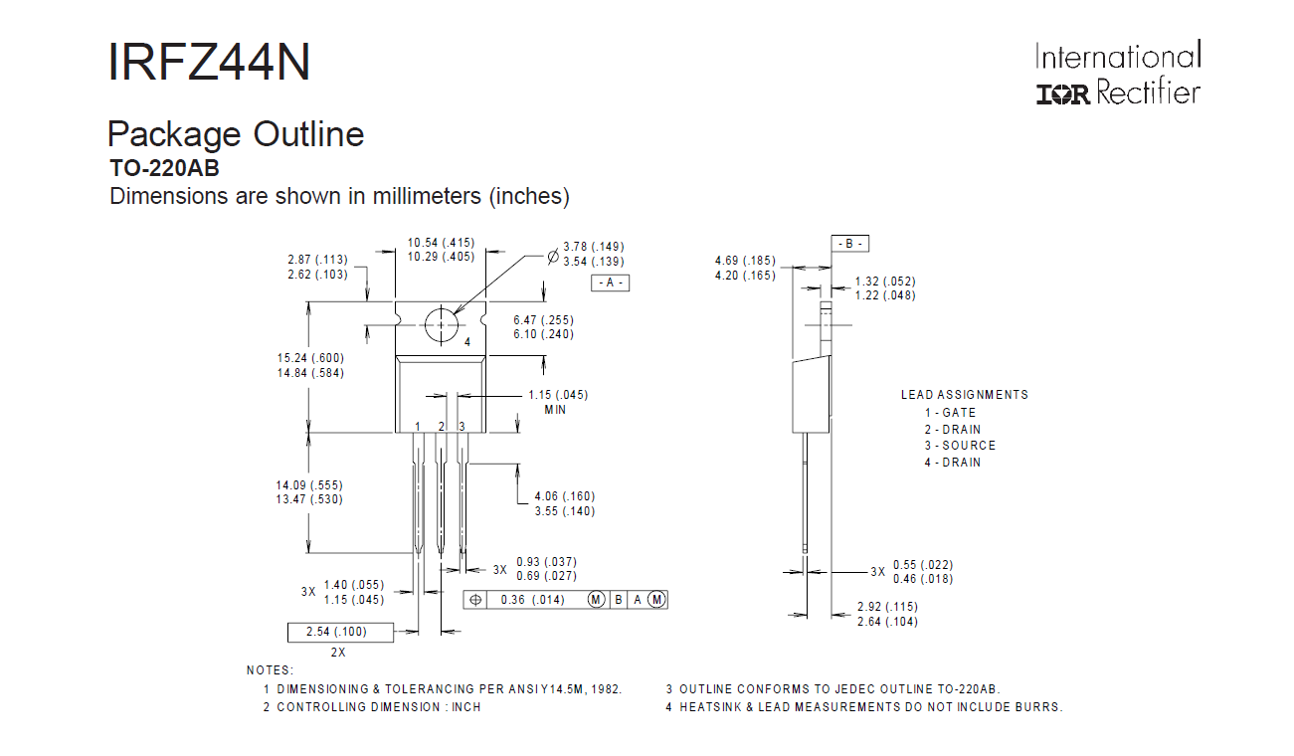

1. Power the motor on a breadboard using the power supply. Please be careful not to exceed the rated voltage of the motor. Verify that the motor works and if it does not report to the TA immediately.  
     
   DO NOT connect an Arduino to your circuit until you have the motor working with the power transistor.
2. Add a power transistor into the circuit and control by connecting the gate to 0V (off) and Vcc (on). Turn off after a few seconds and if the power transistor is warm, do not repeat!  
   Note that most MOSFETS have a maximum Vgs of 20V, so as long as you are using 12V, there is no way you will damage the transistor with too much voltage to the gate.
3. Measure the voltage drop across the power transistor. VSD = 0.014V_________.
4. Measure the current through the circuit. ______0.48A_____
5. Compute the power dissipated by the power transistor. P = ___0.00672W_________  
   Note: even if your power transistor is rated for 9A, there is no way it can take a lot of power unless it is bolted to a large heat sink. However, we don’t have huge motors, so we will not use a heat sink in this lab.
6. Draw the circuit in your CAD package.
7. Shut the power OFF, unplug the Arduino. This is good general safety procedure while working with circuits, particularly when connected to more power than the Arduino itself.

Next Week:

1. Now using the Arduino, connect a digital output to the gate of the MOSFET, and connect ground of the Arduino to ground of the battery/power supply. It is vital to have common ground because if not, the 3.3V or 5V output of the Arduino might float with respect of the power transistor, and then something could be damaged.
2. Measure the voltage drop Vsd = 1.02 V, I = 0.002 A, and power P= 0.00204 W across the transistor with 3.3V from the Arduino. It may be too much for safety. So next, build a 2-stage device to make sure that the gate voltage is high enough. Use 2 power transistors. The first can be controlled with the 3.3V of the Arduino. Using a 5k or 10k resistor, drive the voltage high when the power transistor is disconnected, and low (0V) when it is connected
3. Make the motor turn on for 3 seconds, then off for three seconds (ie blink).
4. Add 50% power by using PWM, pulsing the motor much faster (50 or more times per second).
5. Use analogWrite() and a pin enabled for PWM to enable
6. Power transistor: control (motor)